**Multilevel Inheritance**

**Multilevel inheritance** is a process of deriving a class from another derived class.

C++ Inheritance

When one class inherits another class which is further inherited by another class, it is known as multi level inheritance in C++. Inheritance is transitive so the last derived class acquires all the members of all its base classes.

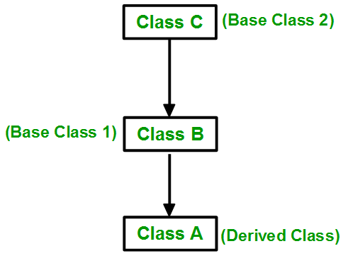

**Exam no 1**

#include<iostream.h>

#include<conio.h>

/* Exam no 1: Multi level inheritance */

class A

{

public: A()

{

cout<<"\n I am in class A";

}

};

class B : public A

{

public: B()

{

cout<<"\n I am in class B";

}

};

class C : public B

{

public: C()

{

cout<<"\n I am in class C";

}

};

void main()

{

clrscr();

C c;

getch();

}

**Exam no 2**

#include<iostream.h>

#include<conio.h>

/* Exam no 2: Multi level inheritance */

**class Grandfather**

{

public: Setdata1()

{

cout<<"\n I have **Car**";

}

};

**class Father** : public **Grandfather**

{

public: Setdata2()

{

cout<<"\n I have **Bike**";

}

};

**class Son** : public **Father**

{

public: Setdata3()

{

cout<<"\n I have **Bicycle** ";

}

};

void main()

{

clrscr();

Son S;

S. Setdata1();

S. Setdata2();

S. Setdata3();

getch();

}

**Output**

I have car

I have Bike

I have Bicycle